FEA Lab Project
NUST-PNEC


Name: Syed Muhammad Haider Hameed
Roll No.: ME-1876
Teacher: Sir Affan
Class: S-VII ME- A
Date: 29/11/2025
Static Structural
- Open Ansys and double click on Static Structural.
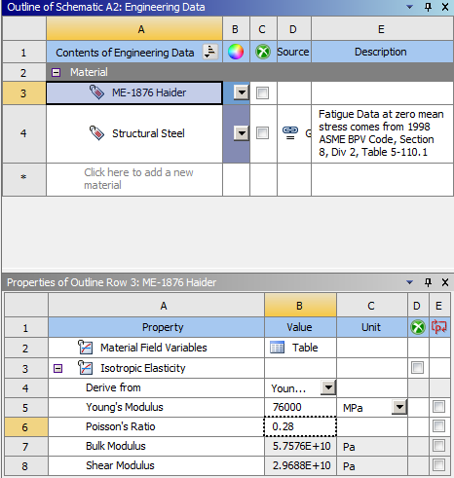
- Double click on engineering data and create your own material and name it your roll number and your name (ME-1876 Haider).
- Select 76000 MPa Young’s Modulus because 76 are the last two digits of roll number, and 0.28 Poisson Ratio.
- Open geometry and select a plane and sketch a pentagon due to even roll number i.e 1876.
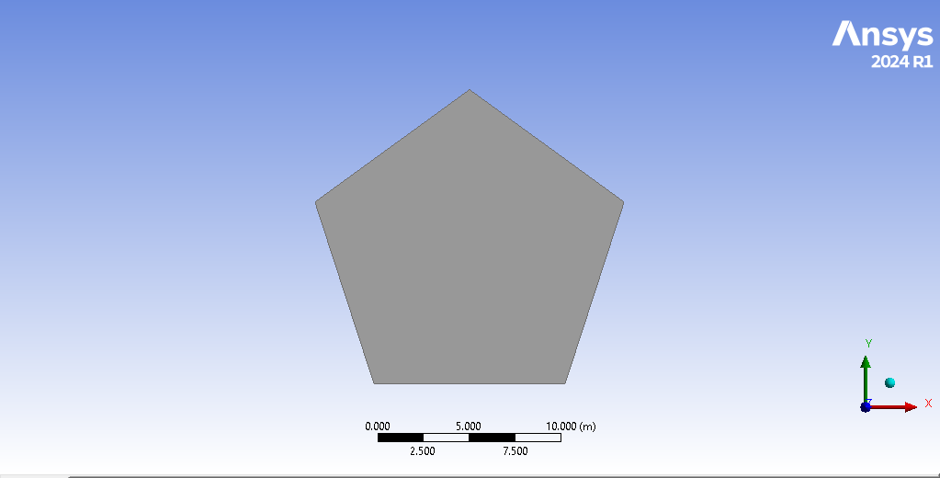
- Click generate and extrude it to 1m.

- Open model and assign the material.
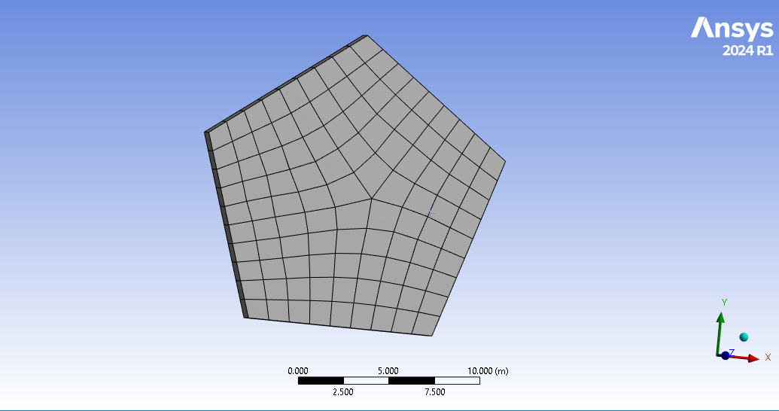
- Generate mesh.

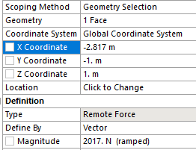
- Make one face fixed support and apply remote force on 1/3rd of the distance; in this case the total distance is 16.904m and 1/3rd will be 5.635m (distance from half will be 2.817m).
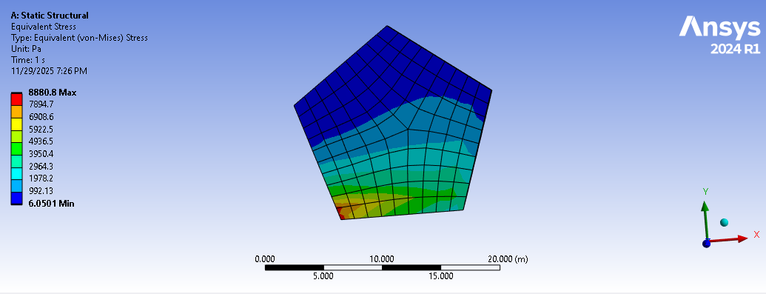
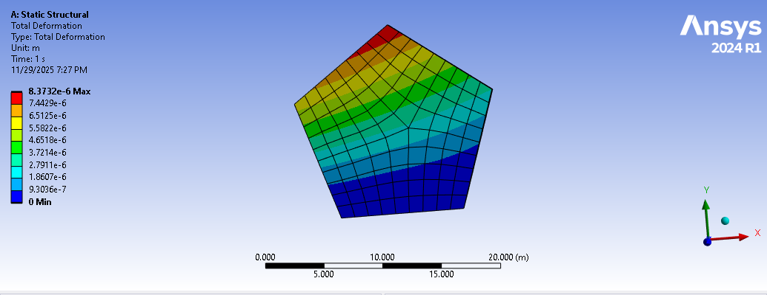
- Calculate the total deformation and equivalent Von-Misses stress.

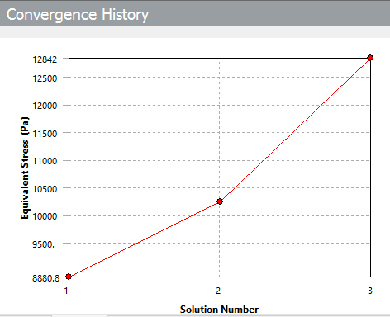
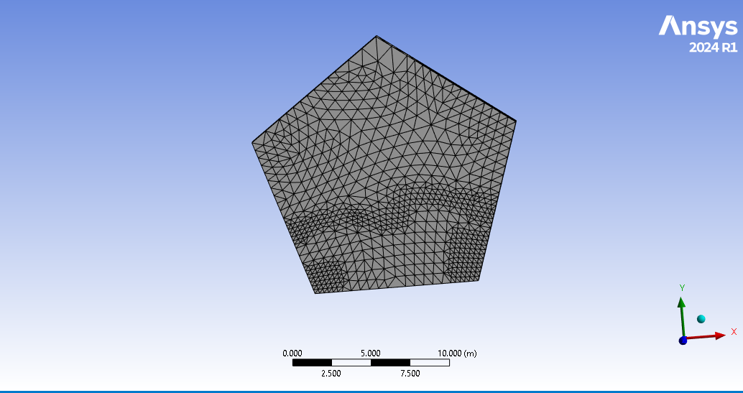
- Calculate mesh convergence.

Transient Structural
- Open Ansys and double click on Static Structural.
- Double click on engineering data and create your own material and name it your roll number and your name (ME-1876 Haider).
- Select 76000 MPa Young’s Modulus because 76 are the last two digits of roll number, and 0.28 Poisson Ratio.
- Open geometry and select a plane and sketch a pentagon due to even roll number i.e 1876.
- Click generate and extrude it to 1m.

- Open model and assign the material.
- Select body sizing of 1m in mesh and generate.
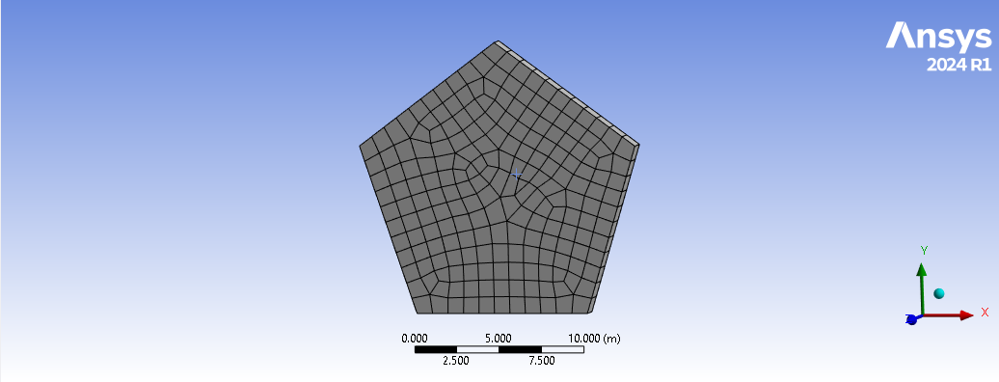

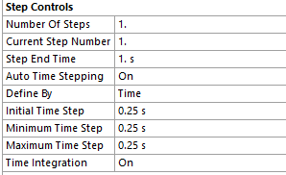
- Go to analysis setting and keep the number of steps 1s and whereas define time steps 0.25s.
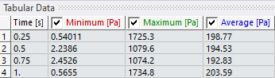
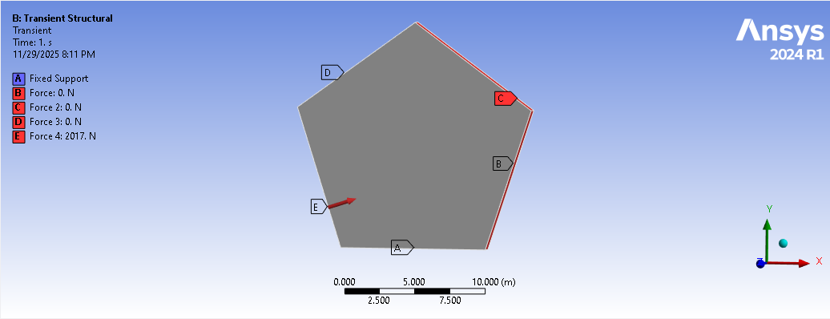
- Apply fixed support to one face and apply forces to different faces, in this case there will be 4 faces. Magnitude of forces will be the sum of your birthday (05/10/2002) = 2017N.

- Calculate equivalent von-misses stress.
